ASSIGNMENT 15

Que 1. Assume there is a table called multicust with all of the same column definations as salespeople write a command that inserts all salespeople with more than one customer into this table.
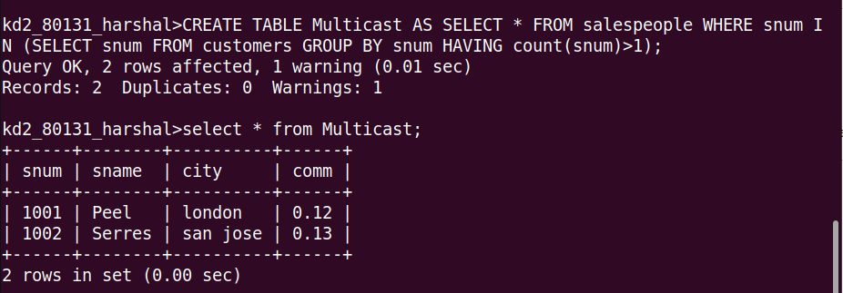

Que 2. Write a command that deletes all customers with no current orders.
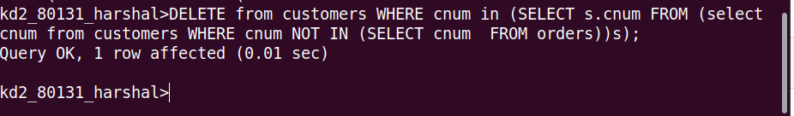
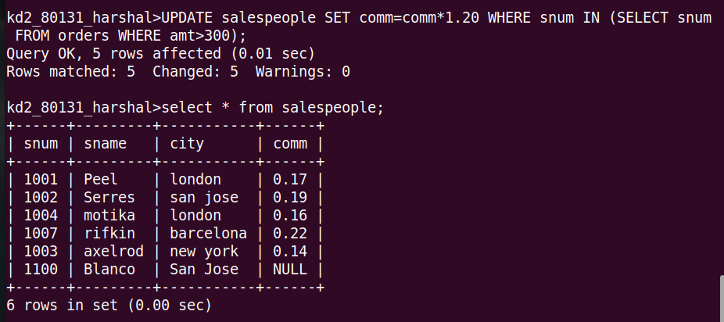
Que 3. Write a command that increases by twenty percent the commisions of all salespeople with total orders above Rs. 3000.

